## A PROJECT REPORT

#### ON

SIGNSENSE

**(A Sign Language Detection System)**

***Submitted by***

#### Bhavishya Chawla (1/21/FET/BCS/269) Ananya Sehgal (1/21/FET/BCS/136) Harsh Mehlawat (1/21/FET/BCS/220)

***Under the supervision of Dr. Suresh Kumar Professor CSE***

***in partial fulfillment for the award of the degree of***

# BACHELOR OF TECHNOLOGY

**IN**

**COMPUTER SCIENCE AND ENGINEERING**



# School of Engineering and Technology Manav Rachna International Institute of

**Research and Studies, NAAC Accredited ‘A++’ Grade Department of Computer Science and**

# Engineering January - June, 2024

## ACKNOWLEDGEMENT

The successful realization of the project is an outgrowth of a consolidated effort of people from desperate fronts. We are thankful to Dr. Suresh Kumar, (Professor) for her variable advice and support extended to us without which we could not be able to complete our project for a success. We are thankful to Dr. Suresh Kumar, Project Coordinator, Professor, CSE department for his guidance and support. We express our deep gratitude to Dr. Mamta Dahiya, Associate Dean & Head of Department (CSE, Normal) for her endless support and affection towards us. Her constant encouragement has helped to widen the horizon of our knowledge and inculcate the spirit of dedication to the purpose. We would like to express our sincere gratitude to Dr. Geeta Nijhawan, Associate Dean SET, MRIIRS for providing us the facilities in the Institute for completion of our work. Words cannot express our gratitude for all those people who helped us directly or indirectly in our Endeavour. We take this opportunity to express our sincere thanks to all staff members of CSE department for the valuable suggestion and also to our family and friends for their support.

#### Bhavishya Chawla (1/21/FET/BCS/269) Ananya Sehgal (1/21/FET/BCS/136) Harsh Mehlawat (1/21/FET/BCS/220)

1

## DECLARATION

We hereby declare that this project report entitled “SIGNSENSE – A Sign Language Detection System” being submitted in partial fulfilment of the requirements for the degree of Bachelor of Technology in **Computer Science & Engineering** under Faculty of Engineering & Technology of Manav Rachna International Institute of Research and Studies, Faridabad, during the academic year 2021-2025, is a bona fide record of our original work carried out under the guidance of **Dr. *Suresh Kumar, Professor CSE.***

We further declare that we have not submitted the matter presented in this Project for the award of any other Degree/Diploma of this University or any other University/Institute.

## Bhavishya Chawla (1/21/FET/BCS/269) Ananya Sehgal (1/21/FET/BCS/136) Harsh Mehlawat (1/21/FET/BCS/220)

2



# School of Engineering & Technology

## MANAV RACHNA INTERNATIONAL INSTITUTE OF RESEARCH

**AND STUDIES, Faridabad NAAC ACCREDITED ‘A++’ GRADE**

January – June, 2024

## CERTIFICATE

This is to certify that this project report entitled “**SignSense - A Sign Language Detection System**” by **Bhavishya Chawla (1/21/FET/BCS/269), Ananya Sehgal(1/21/FET/BCS/136), Harsh Mehlawat (1/21/FET/BCS/220)** submitted in partial fulfilment of the requirements for the degree of Bachelor of Technology in **Computer Science and Engineering** under School of

Engineering & Technology of Manav Rachna International Institute of Research and Studies Faridabad, during the academic year 2023-2024, is a bona fide record of work carried out under guidance of **Dr. *Suresh Kumar, Professor*, CSE.**

### Dr. Suresh Kumar Dr. Mamta Dahiya

Professor Head of Department

### SET, CSE SET, CSE

3

|  |  |  |
| --- | --- | --- |
|  | **TABLE OF CONTENTS** |  |
| **Content:** |  | **Page No.** |
| **Acknowledgement** |  | **1** |
| **Declaration** |  | **2** |
| **Certificate** |  | **3** |
| **List of Tables** |  | **5** |
| **List of Figures** |  | **6** |
| **Abstract** |  | **7** |
| **References** |  | **28** |

4

#### LIST OF TABLES

#### Chapter 1. Introduction

* 1. Introduction
  2. Problem in existing system
  3. Problem Definition
  4. Feasibility Study
  5. Motivation
  6. Project Overview
  7. Hardware and Software Specifications
  8. Overview of the Report
  9. Overview of the report

#### Chapter 2. System Analysis & Design

* 1. Requirement Specification
  2. Flowchart
  3. Design and Test Steps

#### Chapter 3. Implementation and Results

* 1. Design and Test Steps
  2. Code Explanation
  3. Results
  4. Accuracy and Confusion Matrix

#### Chapter 4. Conclusion and Future Enhancements

* 1. Summary of work done
  2. Scope of future enhancement

5

#### LIST OF FIGURES

|  |  |  |
| --- | --- | --- |
| **Figure** | **Figure Description** | **Page No.** |
| **1** | Sign Language Hand Gestures | **9** |
| **2** | Hand Landmarks | **14** |
| **3** | Hardware software specifications | **15** |
| **4** | Tracked 3D hand landmarks are represented by dots in different shades, with the brighter ones denoting landmarks closer to the camera. | **17** |
| **5** | Flowchart MediaPipe | **18** |
| **6** | Node Mapping of Image using MediaPipe | **19** |
| **7** | MediaPipe hands solution graph | **19** |

6

# ABSTRACT

The main topics of **SignSense - A Sign Language Detection System** are covered in this chapter. It begins with a succinct discussion of the motives and needs, then moves on to a summary of sign linguistics and its influence on the subject. In order to examine the features that can be recovered, the types of data that are available and their respective advantages are studied. Before summarizing some of the approaches to the non-manual parts of sign languages, it is first described how to categories the manual aspects of sign (which are comparable to gestures) from a tracking and non- tracking viewpoint. There are several ways to combine the findings of sign classification into a comprehensive SIGNSENSE, demonstrating the development of speech recognition technology and the additional modifications needed for the case of signs. The most recent research is given, and the current horizons are discussed. This discusses how to mix diverse sign modalities efficiently, continuous sign recognition, working toward complete signer independence, utilizing recent linguistic research, and adjusting to larger, noisier data sets.

7

# CHAPTER 1 - Introduction

## Introduction

The project aims to develop an innovative system for real-time sign language recognition and text translation, addressing communication challenges faced by individuals with hearing impairments. The system interprets sign language gestures captured by a camera, converting them into text for seamless communication. The system interprets sign language gestures captured by a camera, converting them into text for seamless communication. The purpose of this work is to contribute to while automatic speech recognition has now advanced to the point of being commercially available, automatic Sign Language Recognition is still in its infancy. Currently all commercial translation services are human based, and therefore expensive, due to the experienced personnel required field of automatic sign language recognition. We focus on the recognition of the signs or gestures.

Very few people understand sign language. Moreover, contrary to popular belief, it is not an international language. Obviously, this further complicates communication between the Deaf community and the hearing majority. The alternative of written communication is cumbersome, because the Deaf community is generally less skilled in writing a spoken language [17]. Furthermore, this type of communication is impersonal and slow in face-to-face conversations. For example, when an accident occurs, it is often necessary to communicate quickly with the emergency physician where written communication is not always possible. The purpose of this work is to contribute to the field of automatic sign language recognition. We focus on recognizing signs or gestures. There are two main steps in building an automated system to recognize human actions in spatial and temporal data [15]. The first step is to extract the features from the frame sequence. This will result in a representation consisting of one or more feature vectors, also known as descriptors. This representation will aid the computer to distinguish between the possible classes of actions. The second step is the classification of the action. A classifier will use these representations to discriminate between the different actions (or signs). In our work, the feature extraction is automated by using convolutional neural networks (CNNs). An artificial neural network (ANN) is used for classification.

8

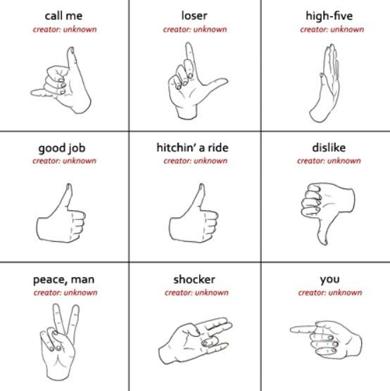

#### Fig. 1 Sign Language Hand Gestures

While automatic speech recognition has now advanced to the point of being commercially available, automatic Sign Language Recognition (SIGNSENSE) is still in its infancy. Currently, all commercial translation services are human-based, and therefore expensive, due to the need for experienced staff. SIGNSENSE aims to develop algorithms and methods to correctly identify a sequence of generated signs and to understand their meaning. Many SIGNSENSE approaches mistakenly treat the problem as gesture recognition. Therefore, research to date has focused on identifying the optimal features and classification methods for accurately labelling a given marker from a set of possible markers. However, sign language is more than just a set of clearly specified gestures.

Sign Language poses the challenge of multichannel; convey meaning through multiple modes at the same time. Although research into sign language linguistics is still in its infancy, it is clear that this makes many of the techniques used for speech recognition unsuitable for SIGNSENSE. In addition, publicly available datasets are limited in both quantity and quality, which makes many traditional computer vision algorithms unsuitable for the task of building classifiers. Due to human translation costs and lack of translation tools, most public services are not translated into signs. There is no commonly used form of written sign language, so all written communication is in the local spoken language.

We worked with some sign language basics before discussing the types of data available and methods of acquiring them. This is followed by a discussion of the features used for the SIGNSENSE and the methods for combining them. Finally, current research limitations and related works are presented as an overview of the state of the art.

9

## Problem in existing systems

Theoretical analysis is predicated on however individuals understand data concerning their surroundings, nevertheless it's in all probability the foremost tough to use effectively. Many completely different ways are tested up to now. The primary is to create a three-dimensional human hand model. The model is compared at hand pictures with one or additional cameras, and therefore the parameters are comparable to the shape of the palm and thus the square measure of the combined angles can be calculated. These parameters are then squared to produce the bit fraction. [7] The second is to ask the camera to misprocess the image and extract the binding options and the squared person options to be used as input to the partitioning algorithm rule for splitting.

## Problem Definition

In our society we have people with disabilities.

* The technology is developing day by day but no significant developments are undertaken for the betterment of these people.
* About 63 million people in the world are deaf and mute.
* Communication between deaf-mute and a normal person has always been a challenging task.
* Sign language helps deaf and dumb people to communicate with other people.
* But not all people understand sign language.

## Feasibility Study

#### Sign-Language Recognition

There exist two primary kinds of sign language recognition that are namely- continuous sign language recognition and isolated sign language recognition. The main distinction between the two categories is the supervisory data.

While isolated sign language recognition is comparable to the action recognition field, continuous sign language recognition is more concerned with accurate alignment between the input video segments and the appropriate sentence-level labels than just the recognition problem itself.

10

Recognition of continuous sign language is generally more difficult than recognition of isolated signs. It is possible to classify isolated sign language recognition as a subset of continuous sign language recognition.

To evaluate the effectiveness of continuous sign language recognition, two important factors— feature extraction from input video frame sequences and alignment—must be taken into consideration.

Between each video segment's features and the accompanying sign label. A continuous sign language recognition system might perform better if it can extract more descriptive and discriminative characteristics from the video frames.

There is still much room for performance improvement in continuous sign language recognition, even though current models show a rising trend in model performance based on deep learning skills in computer vision and NLP.

Only a few of the potential future directions in this field include taking into account the attention mechanism, utilizing multiple input modalities to gain the most from multi-channel information, learning structured Spatio-temporal patterns (using models of Graph Neural Networks), and applying the prior knowledge of sign language.

#### Sign Linguistics

Sign linguistics is the study of languages in the visual modality.

How widely varying are sign languages worldwide? Is the construction of individual signs and signed sentences the same throughout various languages? What are the guidelines for communicating in sign language? How are sign languages taught to kids and adults? How does the brain translate sign languages? Since there are more than thirty different sign languages, it can be challenging to understand every subtle nuance of their semantics. These issues, as well as many others, are related to sign linguistics.

Sign language linguistics is one of the younger areas of linguistic research, having been a field in its own right only since the 1960s, it has only been one of the more recent fields of linguistic study. The early study concentrated on proving the linguistic standing of sign languages—that they are in fact languages in their own right, equivalent to spoken languages—because historically sign language was thought not to be language at all but only a gesture-based help for basic communication.

11

The phonological structure of sign languages, notably American Sign Language (ASL), was studied in the initial studies using conventional linguistic techniques, and it was shown that sign languages had dual patterning. However, the discipline quickly expanded in all directions.

Over the ensuing decades, more thorough studies on the learning and use of sign language, as well as phonological and grammatical analyses of sign languages, have all been published.

With time, a variety of new models for describing the syntax and phonology of sign languages were developed, and existing theoretical models for spoken language were also applied to sign languages.

Cross-modal comparisons with spoken languages as well as cross-linguistic studies on various sign languages and various social contexts (such as urban versus rural sign languages) are both growing in popularity.

The study of sign language in artistic use (such as poetry), frequently in close association with the subject of linguistics, has become one of the main topics of exploration in applied fields of linguistics, along with teaching and interpretation. hearing studies

Particularly in the fields of language emergence and the underpinnings of human cognition, the interface between gesture and sign language has become a hot topic.

Finally, the study of sign language has been included in the field of neurolinguistics.

#### American Sign Language

The sign language used by Deaf people in the United States of America and most of Anglophone Canada is American Sign Language (ASL), a natural language.

Beyond North America, ASL dialects and ASL-based creoles are used in many other nations, including much of West Africa and parts of Southeast Asia.

ASL is a comprehensive and ordered visual language that is represented by using both manual and nonmanual characteristics. As a lingua franca, ASL is also commonly studied as a second language. French Sign Language is most closely similar to ASL (LSF). Although ASL exhibits characteristics untypical of creole languages, like agglutinative morphology, it has been argued that ASL is a creole language of the LSF.a condition of linguistic interaction at the American School for the Deaf (ASD) in West Hartford, Connecticut, in the early 19th century.

Since then, deaf community organizations and schools for the deaf have widely promoted the use of ASL. ASL users have not been accurately counted despite their widespread use. According to reliable estimates, there are between 250,000 and 500,000 ASL users in the United States, including many hearing people and children of deaf adults.

12

## MOTIVATION

Sign language is learned by deaf-mute people and usually normal people don't know it, so it becomes a challenge in communication between normal people and deaf people. It hits our mind to bridge the gap between deaf people and normal people to facilitate communication.

The Sign Language Recognition (SIGNSENSE) system receives an input phrase from a deaf person providing output to a normal person in the form of text or speech.

Hand gesture recognition system is widely used technology for helping the deaf and dumb people. Human hand has remained a popular choice to convey information in situations where other forms like speech cannot be used.

We aim for developing a deaf and dumb gesture recognize system for establishing communication between the deaf and the dumb people. Gestures are considered as the most natural expressive way for communications between humans and computers in virtual systems. Hand gestures which can represent ideas using unique shapes and finger orientation have a scope for human machine interaction. It allows deaf and dumb people to communicate with others. It is the best device for these people to overcome their disability. They can express their views to others. This hand gesture recognition system can be used for interfacing between computer and human using hand gestures.

## Project Overview

Sign language is an important means of communication for the deaf and dumb. Since sign language is a well-structured gesture, each sign has a meaning. In recent years, the interest of researchers in the field of sign language recognition has increased to introduce human-human interaction capabilities to computers. Deaf people rely on sign language interpreters to communicate. However, finding experienced and qualified translators for your daily tasks throughout life is very difficult and they are also valuable.

The objective of this project was to form a neural network that would distinguish between the Yankee language (ASL) alphabet characters, if a written signature is provided. This project is the opening move in making a possible language translator, which may take communication in language and translate it into written and oral language. Such a translator will greatly scale back

13

the barrier between several deaf and onerous of hearing individuals in order that they'll communicate with others in their daily activities.

|  |
| --- |
|  |
| **Fig 2 Hand Landmarks.** |

## Hardware and Software Specifications

List of hardware and software requirements to develop the project “Assistive Technology for deaf and mute”

1. Matplotlib
2. Tensorflow
3. Python
4. Machine learning
5. Keras
6. Camera

14

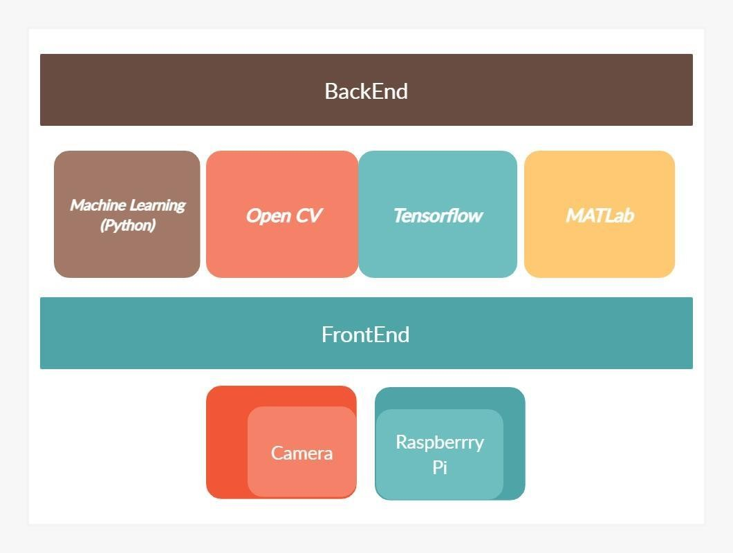

**Fig 3 Hardware software specifications**

## Overview of The Report

The main topics of v **SignSense - A Sign Language Detection System** are covered in this chapter. It begins with a succinct discussion of the motives and needs, then moves on to a summary of sign linguistics and its influence on the subject. In order to examine the features that can be recovered, the types of data that are available and their respective advantages are studied. Before summarizing some of the approaches to the non-manual parts of sign languages, it is first described how to categorize the manual aspects of sign (which are comparable to gestures) from a tracking and non- tracking viewpoint. There are several ways to combine the findings of sign classification into a comprehensive SIGNSENSE, demonstrating the development of speech recognition technology and the additional modifications needed for the case of signs. The most recent research is given, and the current horizons are discussed. This discusses how to mix diverse sign modalities efficiently, continuous sign recognition, working toward complete signer independence, utilizing recent linguistic research, and adjusting to larger, noisier data sets.

15

# Chapter 2 - System Analysis and Design

## Requirements Specifications

#### MediaPipe

The ability to perceive hand shapes and movements can be a key component to improving user experience across many technology fields and platforms. For example, it can form the basis for understanding sign language and controlling hand gestures, and it can also enable the overlay of digital content and information on the physical world in augmented reality.

Although it comes naturally to people, powerful real-time hand recognition is a challenging computer vision task, as hands often obscure themselves or each other (e.g. knuckle/palm and handshake) and lack of high contrast patterns.

MediaPipe Hands is a highly accurate finger and hand tracking solution. It uses machine learning (ML) technology to infer 21 3D landmarks of a hand from a single image.

We hope that bringing this hand recognition functionality to the wider research and development community will lead to the emergence of innovative use cases, stimulating applications and research avenues. new rescue.

16

|  |
| --- |
|  |
| **Fig 4 Tracked 3D hand landmarks are represented by dots in different shades, with the**  **brighter ones denoting landmarks closer to the camera.** |

#### Introduction to MediaPipe

MediaPipe is a framework for building machine learning processes to process time series data like video, audio, etc. This cross-platform framework works on Desktop/Server, Android, iOS and embedded devices like Raspberry Pi and Jetson Nano.

#### MediaPipe Toolkit

The MediaPipe Toolkit includes Frameworks and Solutions. The following diagram shows the components of the MediaPipe Toolkit.

17

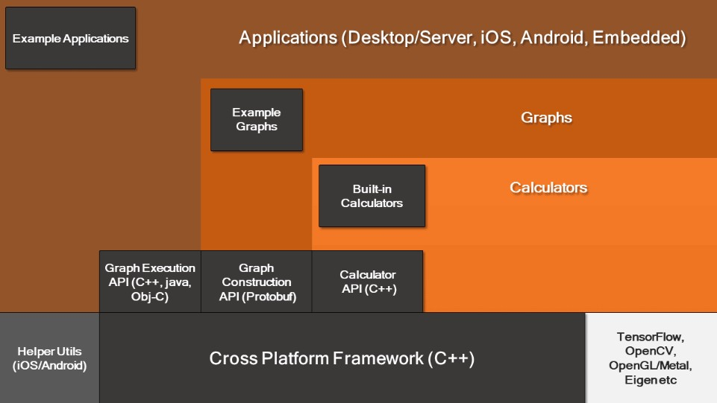

#### Fig 5 Flowchart MediaPipe

* + 1. **Framework**

The Framework is written in C++, Java, and Obj-C, and includes the following APIs.

* + - 1. Calculator API (C++).
      2. Graph Building API (Protobuf).

#### Graphs

The MediaPipe cognitive pipeline is called a graph. Let's take the first solution as an example, Hands. We provide an input image stream with manual markers displayed on the image.

18

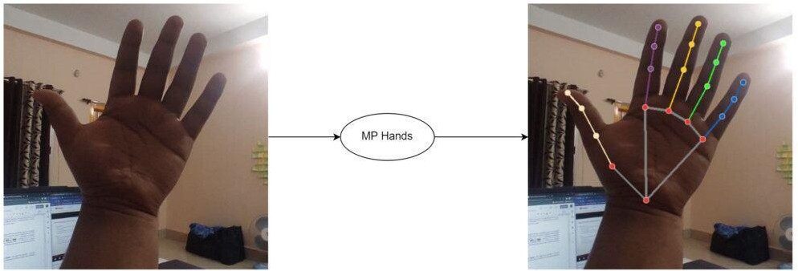

**Fig 6 Node Mapping of Image using MediaPipe**

## The flowchart below represents the MP (Abbr. MediaPipe) hand solution graph.

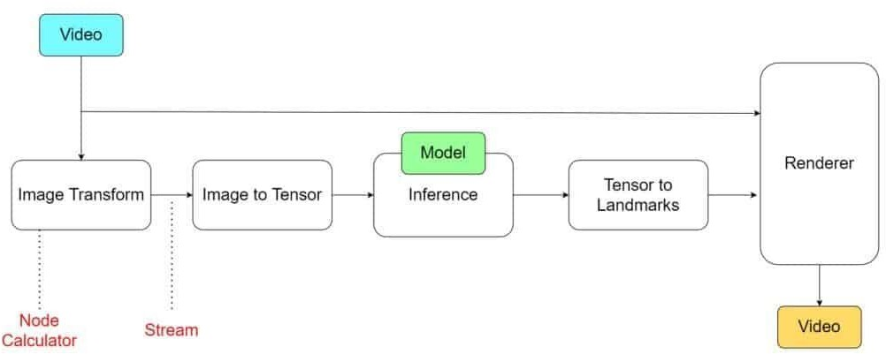

#### Fig. 7 MediaPipe hands solution graph

In computer terms, a graph consists of nodes connected by edges. Inside a MediaPipe graph, the nodes are called calculators and the edges are called streams. Each stream carries a sequence of packets with increasing timestamps.

In the image above, we have represented the pocket calculators with rectangular blocks and the flow with arrows.

#### 2.2.1 Use case of MediaPipe

For machine learning (ML) teams, software engineers, or students and academics who publish code and prototypes as part of their research, MediaPipe was created. The MediaPipe framework is

19

especially intended for the quick evolution of perception pipelines that include reusable parts and AI models for inferencing. Additionally, it makes it easier to integrate computer vision software into applications and demos operating on many hardware platforms. Teams can incrementally enhance computer vision pipelines thanks to the configuration language and evaluation tools.

## Design and Test Steps

#### Palm Detection Model

To detect the initial positions of the hand, we designed a single-shot detection model optimized for mobile device use in real time according to the similar face detection model in MediaPipe Face Mesh. Hand detection is a very complex task: both our simplified model and our full model have to work on many different hand sizes with a large (~20x) aspect ratio to the frame and can detect covered hands and cover themselves. Although faces have high-contrast patterns, such as in the eye and mouth areas, the absence of such features in the hands makes their detection reliable from only the visual features of the face. They are relatively difficult. Instead, providing additional context, such as arm, body or person features, makes it easier to determine the exact position of the hand. Our approach addresses these challenges with different strategies. First, we train the palm detector instead of the hand detector, because it is much easier to estimate the bounding boxes of hard objects such as palm and fist than to detect the hand with knuckle fingers. Also, because the palm is a smaller object, the non-maximal suppression algorithm works well even for cases of self-covering with two hands, such as handshakes. Alternatively, palms can be modeled using square bounding boxes (anchors in ML terms) ignoring other aspect ratios and thus reducing the number of anchors by a factor of from 3 to 5. Second, the encoder-decoder feature extractor is used to take a closer look at the context, even for small objects (similar to the Retina Net approach). Finally, we minimize the focus loss during training to support a large number of anchors due to large-scale variance.

With the above techniques, we get an average accuracy of 95.7% in palm detection. Using the usual cross-entropy loss and no decoder yields a baseline of just 86.22%.

20

# Chapter 3 - Implementation and Results

## Design and Test Steps

The provided code implements a comprehensive pipeline for gesture recognition using real-time webcam feed. It utilizes the MediaPipe library for landmark detection, OpenCV for image processing, and TensorFlow-Keras for machine learning. The pipeline begins with data collection, where keypoints representing face, pose, and hand landmarks are extracted from video frames and saved as numpy arrays. These data are then organized into sequences and labeled based on the performed actions. A deep learning model consisting of LSTM layers followed by dense layers is defined and trained on the prepared dataset. Hyperparameters are tuned, and regularization techniques are applied to improve generalization performance. Real-time prediction and visualization loops are established, where frames from the webcam feed are processed, and actions are predicted using the trained model. To enhance accuracy to 0.8, augmentation techniques, hyperparameter tuning, complex model architectures, regularization, and potentially transfer learning can be employed to optimize the system further.

## Code Explaination:

Here's a detailed breakdown of how the code functions:

1. Imports: The script starts with importing necessary libraries including OpenCV, NumPy, Matplotlib, MediaPipe, and others for image processing, data manipulation, and machine learning.
2. MediaPipe Detection Functions: There are functions defined to facilitate the detection and drawing of landmarks using the MediaPipe library. These functions are used to detect face, pose, and hand landmarks in the video frames.
3. Video Capture: The script initializes a video capture object from the webcam (or any available camera).
4. Main Loop for Data Collection:

21

* + Inside a `while` loop, frames from the webcam feed are continuously read.
  + Each frame is passed through the MediaPipe detection functions to obtain landmark detections.
  + Landmarks are drawn on the frame using specified drawing functions.
  + The annotated frame is displayed in a window using OpenCV.
  + Keypoints extracted from the landmarks are saved as numpy arrays for each frame.
  + The process repeats until the user interrupts by pressing 'q'.

1. Data Preparation for Machine Learning:
   * After data collection, the script organizes the collected keypoints into sequences, each representing a specific action or gesture.
   * It prepares labels for these sequences based on the actions being performed.
   * The data is split into training and testing sets for model training and evaluation.
2. Model Architecture Definition:
   * A sequential deep learning model is defined using Keras.
   * The model consists of multiple LSTM layers followed by dense layers for classification.
3. Model Training:
   * The model is trained using the prepared training data.
   * TensorBoard callback is used for monitoring training progress.
4. Model Evaluation:
   * The trained model is evaluated using the testing data.
   * Metrics such as categorical accuracy and confusion matrix are computed.
5. Real-time Prediction and Visualization:
   * Finally, a real-time prediction loop is established.
   * Frames from the webcam feed are processed similarly to the data collection phase.
   * Keypoints are extracted and passed through the trained model to predict the action being performed.

22

* + Predictions are visualized on the frame, and a sequence of actions is maintained to form a meaningful sentence.

The code is well-structured, integrating real-time data collection, machine learning model training, and inference seamlessly. It's a comprehensive pipeline for gesture recognition and could be further extended for various applications like sign language recognition, activity recognition, etc.

## Results:

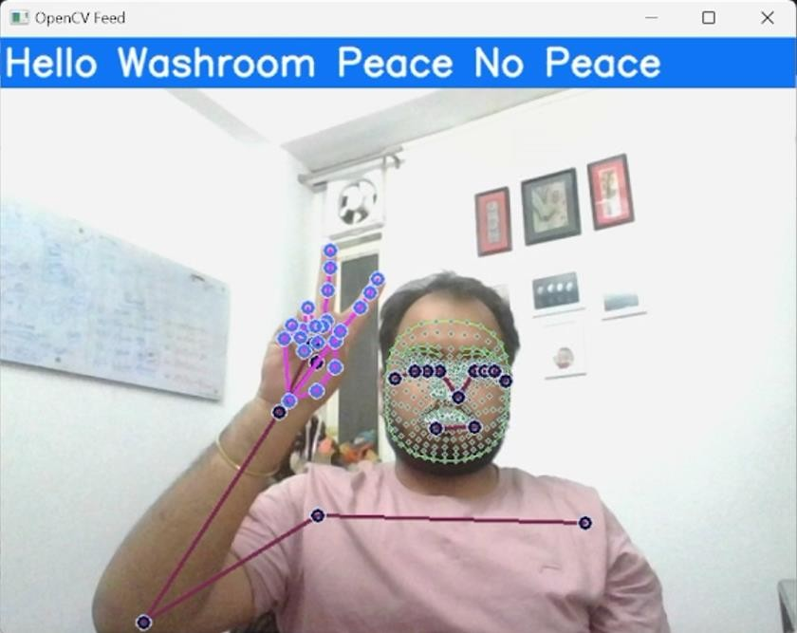

23

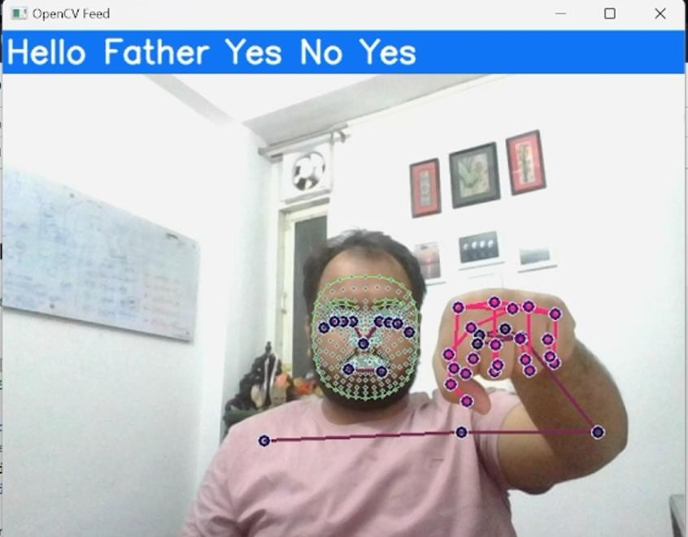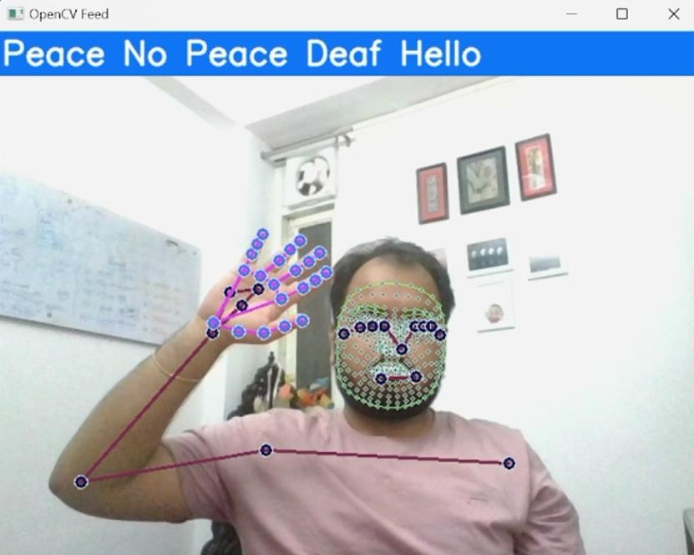

24

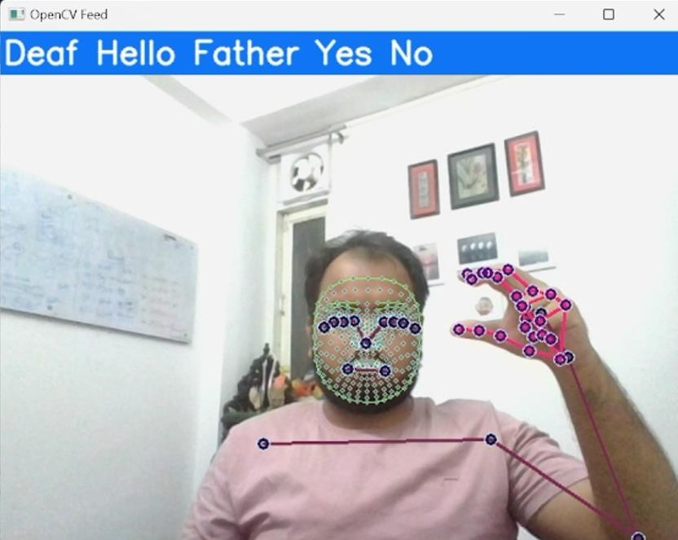

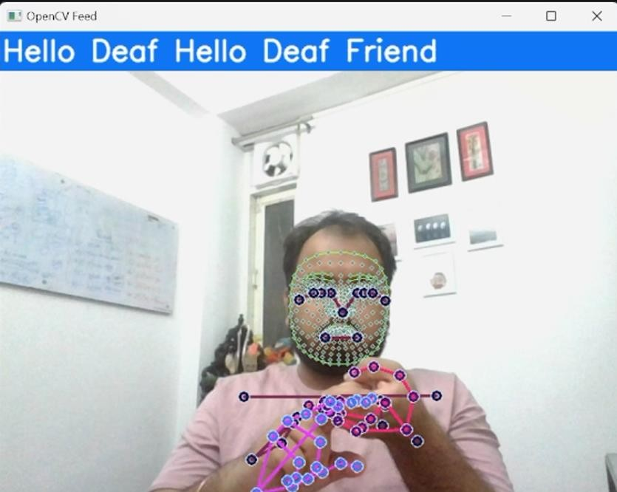

25

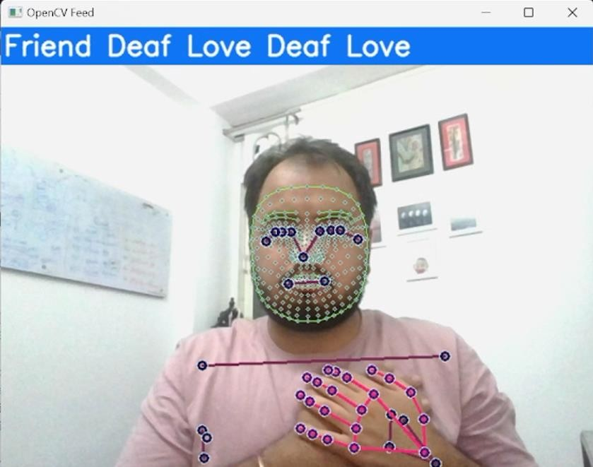

## Accuracy and Confusion Matrix:

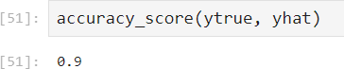

26

# Chapter 4 - Conclusion and Future Enhancement

## Summary of work done

The primary objective of this project was to develop a neural network capable of recognizing American Sign Language (ASL) alphabet characters from provided hand gestures. This initiative marks the initial step towards creating a potential language translator that could facilitate communication by translating sign language into written and spoken language, thereby reducing communication barriers for individuals who are deaf or hard of hearing in their daily interactions. While automatic speech recognition technology has progressed significantly and is now commercially available, sign language recognition, represented here by the project SIGNSENSE, is still in its nascent stages.

Presently, commercial translation services rely on human interpreters, making them costly due to the requirement for skilled personnel. SIGNSENSE aims to overcome this limitation by developing algorithms and methodologies to accurately identify sequences of generated signs and comprehend their meanings. While traditional approaches to sign language recognition often treat the problem as gesture recognition, it's essential to recognize that sign language encompasses more than just a series of predefined gestures. As such, research in this area is focused on identifying optimal features and classification methods to accurately interpret a given sign from a set of possible signs.

## Scope of future enhancement

In order to enhance the performance of the gesture recognition system, one avenue for improvement lies in augmenting the dataset to encompass a wider range of variations. This includes introducing variations in lighting conditions, backgrounds, and hand orientations to make the model more robust to real-world scenarios. By diversifying the dataset, the model can better generalize across different environments and lighting conditions, ultimately improving its accuracy and reliability during inference.

Furthermore, optimization of the model architecture presents another opportunity for enhancement. While the current implementation utilizes LSTM layers for temporal sequence modeling, integrating convolutional neural networks (CNNs) for feature extraction from images could be beneficial. CNNs excel at capturing spatial relationships in images, which could complement the temporal modeling capabilities of LSTMs. By incorporating CNNs into the architecture, the model may better capture intricate spatial features within the hand gestures, potentially leading to improved recognition accuracy.

Additionally, fine-tuning of hyperparameters and regularization techniques can further refine the model's performance. Experimentation with learning rates, batch sizes, and dropout rates, coupled with regularization techniques such as L2 regularization or dropout, can help prevent overfitting and improve generalization capabilities. Hyperparameter tuning ensures that the model optimally adapts to the dataset, while regularization techniques mitigate the risk of the model memorizing noise in the training data. Through systematic exploration and optimization of these parameters, the model can achieve a better balance between performance on the training set and generalization to unseen data, ultimately enhancing its accuracy and reliability in real-world applications.

27

## References

* <https://appinventor.mit.edu/explore/about-us>
* Basic Concept of Classification (Data Mining) - GeeksforGeeks <https://www.geeksforgeeks.org/basic-concept-classification-data-mining>
* Hands | mediapipe <https://google.github.io/mediapipe/solutions/hands>
* Learn Game development with MIT APP INVENTOR | Online Live Learning - OLL <https://www.oll.co/course/learn-game-development-with-mit-app-inventor>
* App Inventor <https://appinventorzmk.blogspot.com/>
* subtitlebyte - Blog <https://subtitlebyte.weebly.com/>
* MIT App Inventor Part 1 [https://mitappinventorpart1.blogspot.com/2020/02/mit-app-](https://mitappinventorpart1.blogspot.com/2020/02/mit-app-inventor-part-1) [inventor-part-1](https://mitappinventorpart1.blogspot.com/2020/02/mit-app-inventor-part-1)
* About Us - appinventor.mit.edu <https://appinventor.mit.edu/explore/about-us>
* Full article: Developing Classifiers through Machine Learning ... <https://www.tandfonline.com/doi/full/10.1080/08839514.2021.1901032>
* MediaPipe: Pose Detection in images and videos | by Saaisri ... <https://medium.com/featurepreneur/mediapipe-pose-dectection-in-images-and-videos>
* Introduction to MediaPipe | LearnOpenCV [https://learnopencv.com/introduction-to-](https://learnopencv.com/introduction-to-mediapipe/) [mediapipe/](https://learnopencv.com/introduction-to-mediapipe/)
* layout: default title: Hands parent: Solutions nav_order: 4

<https://mediapipe.readthedocs.io/en/latest/solutions/hands>

* Wood Based Smart Mirror : 12 Steps - Instructables <https://www.instructables.com/Gesture-Controlled-Smart-Mirror>
* Basics: Project 107a MIT App Inventor 2 and Arduino [https://acoptex.com/wp/basics-](https://acoptex.com/wp/basics-project-107-mit-app-inventor-2) [project-107-mit-app-inventor-2](https://acoptex.com/wp/basics-project-107-mit-app-inventor-2)
* About Us | Codeyoung <https://www.codeyoung.com/courses/mit-app-inventor/>

28